**Lab 1 – Project Management Framework**

1. Form a group of 3-4 members.

MEGALA D/O SONTULOM B031910172

NUR IZZATI BINTI SHAFIE B031910476

NUR’AIN NAJIHA BINTI ZAKARIA B031910466

1. Select the title of the project which related to IT and AI.

Fire Detection using Computer Vision

1. Appoint a project manager.

NUR’AIN NAJIHA BINTI ZAKARIA B031910466

1. Based on the lecture slides and related information given in ulearn, discuss the **Project Management Framework** as shown in **Figure 1** when relate to **Artificial Intelligence Project Management** and the chosen title as in step no 2.

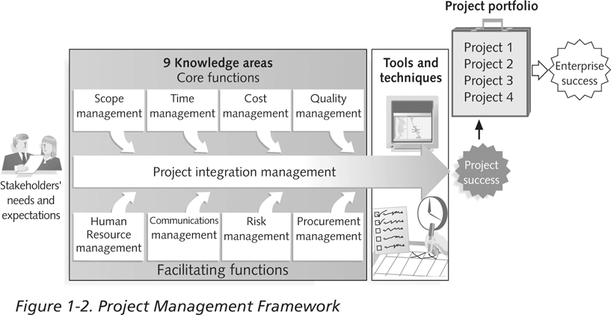

**Figure 1 Project Management Framework**

1. **Scope Management**
2. **Project Manager**

Planning and creating the schedule of the project for the members and making sure every phase will be executed, troubleshooting, developing the budget and monitoring the process.

1. **Project Coordinator**

Will ensure the project will be completed on time and handling the administration part of the project.

1. **Programmer**

Build an algorithm and the system using convolutional neural network.

1. **Designer**

Making sure the system is flexible to install anywhere and how the fire and heat going to appear on the screen.

1. **Cost management**

|  |  |
| --- | --- |
|  | **Costs (RM)** |
| **Project Manager salary** | **5000.00** |
| **Project Coordinator salary** | **4300.00** |
| **Programmer** | **4000.00** |
| **Designer** | **3500.00** |
| **Material** | **500.00** |
| **Total** | **13300.00** |

1. **Time management**

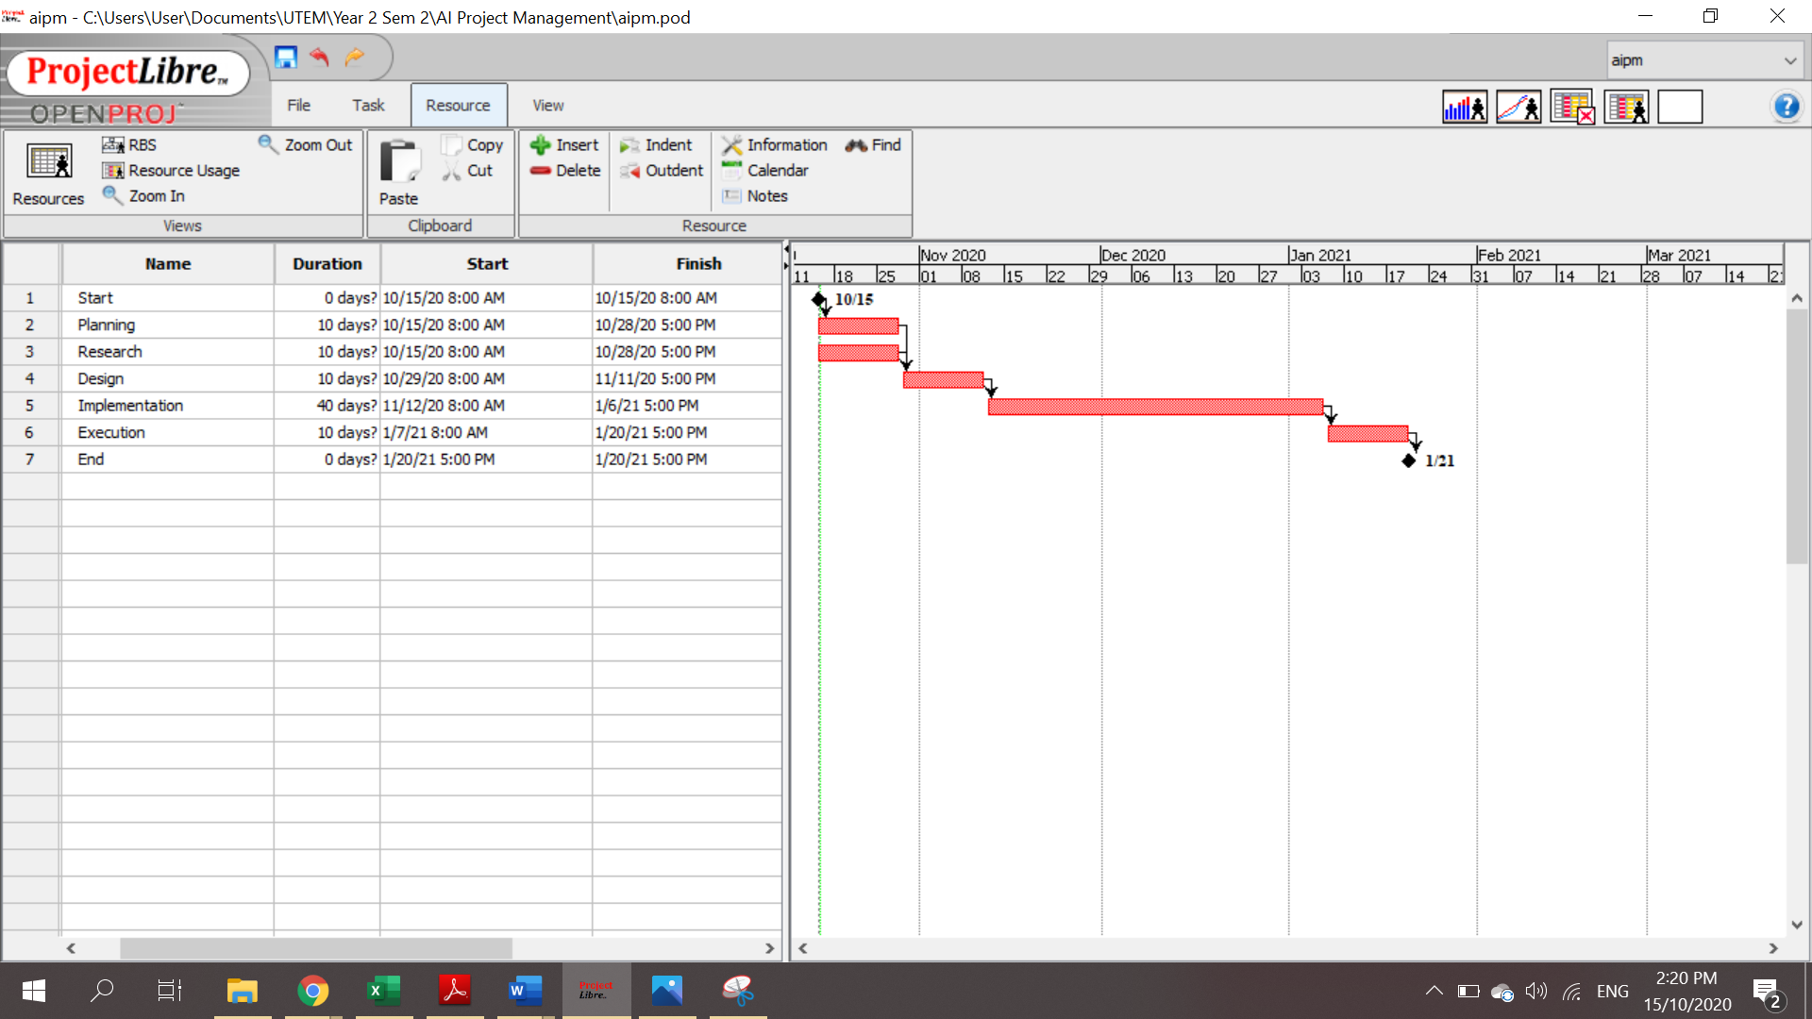

1. **Quality Management**

A set of interrelated or interacting elements of an organisation that establishes policies, objectives and processes to achieve those objectives that are aligned to customer focus and satisfaction through quality services or products. In simple terms a Quality Management System helps you maintain and expand your customer base by putting them first. In addition, help of our management manual and additional process instructions, we document the high demands placed on our quality management system.

* Consumer Focus: Meet consumer standards and surpass them
* Leadership: Provide meaning, direction and involvement.
* People's engagement: recognition of fire, empowerment and strengthening of skills and knowledge.
* Process Approach- Understand processes for performance optimization.
* Improvement- To preserve existing success and to create new possibilities.
* Evidence-based decision-making: Facts, evidence, and decision-making data analysis.
* Relationship management: Maximize efficiency and manage relationships with interested parties.

1. **Human Resource Management**

A systematic approach to the successful management of employees in an enterprise or organization to help them achieve a competitive edge in their business. It is designed to maximize employee efficiency in the pursuit of the competitive goals of the employer. Human resource management is concerned with the advancement of people and the organization in which they work. The fire management plan is one step below the resource management plan, but the former can be developed without the latter being in operation. The fire management plan should discuss all activities listed in this section. In certain cases, it might be better to create individual strategies for selected sections, such as the prevention of fire or the use of scheduled fire. Nevertheless, safety should be a main characteristic, including the fire management strategy.

* All fire prevention policies and operations should be focused on a consistent and detailed strategy, regulatory and structural structure.
* For any type of fire control, including usage, avoidance, fuel management, detection, initial attack, large-fire containment and restoration, plans should be planned at a reasonable level of detail.
* A strategy that sets the protection of firefighters, fire officials and the public as the highest priority should be developed.
* Should provide an overview of activities that enhance or mitigate danger and threats impacting fire activity, fire or profit as well as effects on the protection of firefighters, fire managers and the public.
* Plans should be focused on ecosystem forms, future fire consequences, fire regimes, and natural, economic and social values.
* Companies, departments, municipalities and communities should create a process to include local communities, communities of concern and others in the planning of resource and fire protection plans.

1. **Risk Management**

This will make fire prevention more cost-effective and easy. However, the whole question of trade-offs between structural security and other fire protection systems is complicated and such decisions can only be taken after consultation with your local fire authority. Risk management is the process of recognizing, evaluating and monitoring the risks to the resources and profits of a company. These challenges or threats may occur from a wide range of causes, including financial volatility, legal obligations, strategic management mistakes, incidents and natural disasters. The following is a helpful guide that can help ensure the instigation and preservation of fire precautions to an appropriate level.

* Establishes a healthy and stable work environment for both workers and clients.
* Increases company processes' flexibility while still reducing legal responsibility.
* Provides insurance from activities that are disruptive to both the organization and the environment.
* Protects from possible damage to those concerned persons and belongings.
* Helps to determine the insurance requirements of the company in order to save on unnecessary premiums.

**Risk management strategies and processes**

* + Recognition of risk - The organization recognizes and describes possible risks that may have a detrimental effect on a particular business activity or initiative.
  + Analysis of risk - The purpose of risk analysis is to better understand any individual instance of risk and how it might impact the project and priorities of the organization.
  + Assessment and assessment of risk - The organization will also make decisions about whether the risk is reasonable and whether the organization is prepared to take it on the basis of its risk appetite.
  + Reduction of risk - In the case that the scenario comes to fruition, these strategies include risk control processes, risk management tactics and backup plans.
* Monitoring of threats - Part of the prevention strategy requires the follow-up of both the threats and the general plan to track and monitor new and emerging threats on an ongoing basis.
* Communicating and advising - Internal and external shareholders should be involved in the coordination and consultation process at the relevant stage of the risk assessment process and with respect to the entire process.

1. **Communications Management**

There are several different building structures and principles protected by fire safety. Most of these is the need for reliable emergency communications and other emergency conditions in the case of a fire. Recently, codes have acknowledged that fire alarm systems should be used for emergency communications outside fire cases.

* Detectors must be combined with detectors to be useful.
* Alarm systems provide warning to at least the occupants of the building and typically send a signal either on or off site to a staffed control station.
* In some situations, alarms can go straight to the fire department but this is no longer the usual solution in most areas.
* The only major disadvantage is that the fire is not controlled or regulated by them.
* To manage the fire, suppression systems such as automatic sprinklers operate.
* The system also provides notice that they are running, so that if connected to notice appliances in the building, they will fill the role of a heat detection-based system.

1. **Procurement management**

Fire detection shall be checked in place to ensure smoke and warning response in the sensing chamber. Smoke or listed aerosol testing licensed by the manufacturer must be allowed as suitable test methods. Such manufacturer-approved methods that ensure the entrance of smoke into the sensing chamber are allowed. Each of the following tests shall be carried out to ensure that each smoke detector is within the defined and established sensitivity range:

* Calibrated method of research.
* Manufacturer's calibrated sensibility measurement tool.
* List of control equipment arranged for this purpose.
* Fire Detection Control Unit Arrangement by which the detector causes a signal to the control unit when its sensitivity is below the specified sensitivity level.